Emergency Communication Network for Offline Disaster Management

🧾 Prepared By
Roaa Akram Mohammad Qawareq
Maha Mohammad Adel Safadi
Instructor: Dr. Jihad Hammamra
University: An-Najah National University
Course: Computer Networks

📌 1. Introduction
This project focuses on designing an offline communication network using GNS3. The goal is to ensure communication between devices during internet outages and emergency situations such as disasters.

📌 2. Problem Statement
During natural disasters or infrastructure failures, internet connectivity may become unavailable, leading to breakdown in communication between users and emergency services.

📌 3. Objectives
- Design an offline communication network
- Enable communication between multiple LANs
- Provide access to a local emergency server
- Simulate the network using GNS3
- Ensure reliability during internet failure

📌 4. Network Design
The network consists of:
- AlpineLinux-1 (server)
- Router R1 (Central Device)
- IOSv-L2 Switch
- AlpineLinux-2 and AlpineLinux-3 (Clients)
The router connects the standalone node (Linux1) with the LAN network.

📌 5. Network Topology
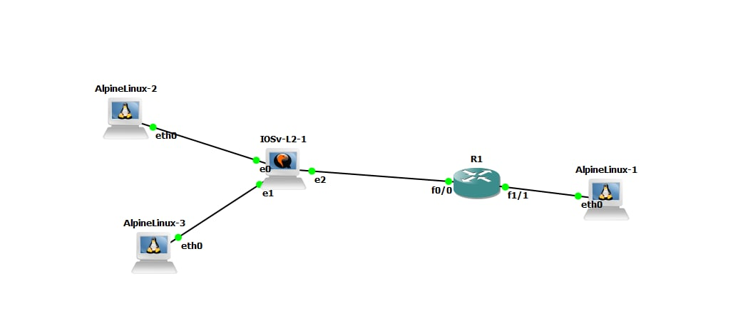
📌 6. LAN Design
LAN 1: 192.168.1.0/24 → AlpineLinux-2 and AlpineLinux-3 (Clients)
LAN 2: 192.168.2.0/24 → AlpineLinux-1 (Server)
📌 7. IP Addressing Plan

AlpineLinux-2: 192.168.1.10
AlpineLinux-3: 192.168.1.20

Router LAN1: 192.168.1.1
Router LAN2: 192.168.2.1

AlpineLinux-1 (Server): 192.168.2.10
📌 8. Router Role
The router is responsible for:
- Connecting different LANs
- Routing traffic between networks
- Ensuring communication between all devices

📌 9. Switch Role
The IOSv-L2 switch operates at Layer 2 and:
- Connects Linux2 and Linux3
- Forwards data using MAC addresses
- Manages local LAN traffic

📌 10. Linux Nodes
AlpineLinux devices act as client machines used for:
- Communication
- Testing connectivity
- Simulating real user devices

📌 11. Emergency Server Concept
A local server can be added to provide:
- Emergency alerts
- Offline instructions
- Local communication services

📌 12. Testing
- Ping between all devices was successful
- LAN communication verified
- Router routing functional
- No internet dependency required

📌 13. Security
The network is isolated from the internet to:
- Prevent external interference
- Ensure controlled communication
- Maintain system reliability

📌 14. Conclusion
The project successfully demonstrates an offline emergency communication network using GNS3. It ensures reliable communication between devices during disasters or internet failures.
📌 15. Access Control List (ACL)
An ACL was implemented on the router to control access to the server.
The goal was to block AlpineLinux-3 from accessing the server while allowing AlpineLinux-2.
Configuration:
access-list 100 deny ip host 192.168.1.20 host 192.168.2.10
access-list 100 permit ip any any
interface f0/0
ip access-group 100 in
Result:
- AlpineLinux-2 can access the server successfully
- AlpineLinux-3 is blocked from accessing the server
📌 16. Chat System
A simple communication system was implemented using netcat (nc).
- AlpineLinux-2 listens on port 1234
- AlpineLinux-3 connects to AlpineLinux-2 using its IP address
This allows real-time communication between users inside the LAN without internet.
📌 17. Emergency Web Server

A local emergency server was implemented using netcat.

The server displays emergency instructions such as:
- Stay Calm
- Evacuate immediately
- Call 911

This service works completely offline and provides guidance during emergencies.

